**Portable EL Device Hardware Design Documentation**

1. **Overview**

This documentation aims to record and explain the hardware design of the portable EL device, including both the electronic design and the mechanical design. As a brief, the portable EL device is an integrated system which uses high-quality IR camera controlled by Raspberry Pi to detect the defection of solar panels. In specific, the electronic design will contain two parts: sensing system and the power supply system.

1. **Electronic Components**

As addressed above, the electronic system is composed by two parts for the portable EL device. In detail, the first part is to control the IR camera by Raspberry Pi microcontroller and the second part is to provide power for solar panels on the purpose of defection detection. The communication between the system is based on the RF module. Therefore, the components being used in the project will be discussed based on the two parts of the system.

**Sensing and Controlling System:**

Raspberry Pi 4B Development Board

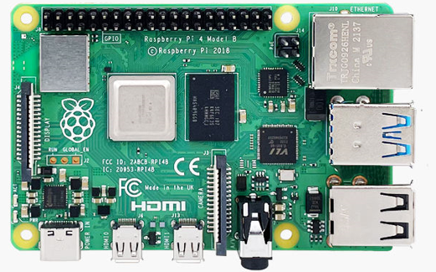

Raspberry Infrared Camera

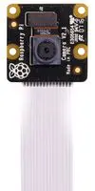

Raspberry Pi Portable Screen

Linx EVAL-433-LR Transmitter Evaluation Board

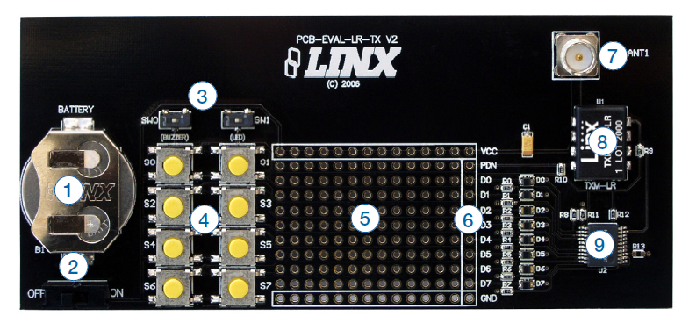

**Power System:**

Linx EVAL-433-LR Receiver Evaluation Board

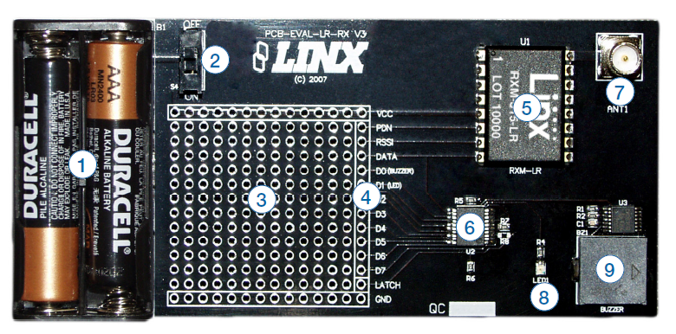

1. **Electronic Circuit Design**

**Sensing and Controlling System:**

As the IR camera and the screen being used are directly from Raspberry Pi, they are designed to be easily compatible with the Raspberry Pi 4B development board. As shown in figure X, there are FPC connectors designed on the development board which can be used to connect the screen and the camera respectively. Hence, by plugging the FPC wires into the connectors, they can be easily hardware-connected.

Other than the Raspberry components, the RF module needs to be connected with the microcontroller as well. In such case, the GPIOs are used to build the hardware wiring. As shown in figure X, GPIO port 4 and 5 on the Raspberry Pi development board are used to communication with the RF transmitter module. In specific, GPIO 4 is connected with PDN port to ensure the RF transmitter in the working mode. GPIO 5 is connected with the DATA port to send the trigger signal out. Also, 3.3V Vcc and GND are connected accordingly.

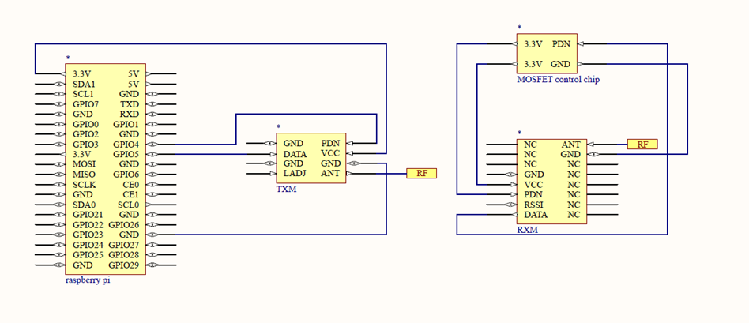

1. **Mechanical and Electrical Components**

The current regulator was built based on the following circuit schematics.

The following tables showcase the electrical components that have been used to create the current regulator device. The table also shows the rating of each component.

|  |  |  |
| --- | --- | --- |
| Part | Description | Rating |
| HV9910C | The main chip that acts as the regulator. | 15V-450V, max temp of 125C |
| Resistor R1 | Resistor that connects to pin 8 of the chip (RT) | 240 k |
| Resistor R2 | Resistor that is used to step down the voltage to 5V | 18 k |
| R3 (potentiometer) | Help adjust the amount of current required. | 1k |
| Resistor R4 | Connected to the potentiometer | 18k |
| Resistor R5 |  | 17k |
| Resistor R6 | A surface mount style resistor | 50m |
| Resistor R7 | A surface mount styled resistor | 50m |
| Capacitor C1 | Connects to pin 6 of the chip (VDD) | 1 |
| Capacitor C2 | Connects to pin 7 (LD) of the chip | 0.1 |
| Capacitor C3 |  | 330 , 63V |
| Capacitor C4 | Connects to pin 1 (Vin) of the chip | 0.1 |
| Capacitor C5 | Added before current enters the panel | 1 |
| Zener diode |  | - |
| Switch | Normal 5V switch to activate the circuit | - |
| MOSFET | Used to connect the chip to the circuit and panel | 100V, 45A rating |
| Diode D2 | Schottky styled rectifier | 100V, 20A |
| Inductor L1 | Toroidal styled inductor | 380 |

In terms of the mechanical components one of the criteria that the client had set for us was to fit everything in a box. The box contains the current regulator and the RF receiver. The box dimensions are 222x146x75 mm and is made of ABS plastic. The box has a water and dust resistance rating, but since holes are cut in the box, the ratings no longer hold true.

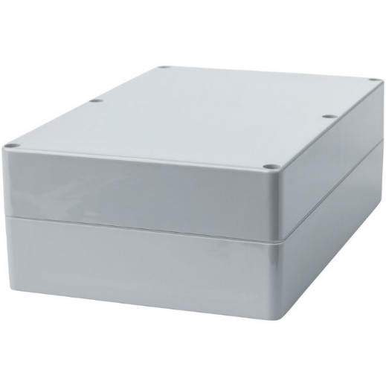

The circuit regulator is built on a copper cladding board, with the electrical components directly soldered onto the board. The board is also attached to an aluminum plate that acts as a base as well as a heat sink, dissipating heat from the copper clad and distributing the heat onto a larger area.

|  |  |
| --- | --- |
| CIF ADB16 | Raw Aluminium surface Square Art Boards |

Utilising the given space and the componenets tht needed to be soldered, the copper clad was cut accordingly. The aluminium plate acts as the mounting plate for the circuit to be fit into the box. The picture below shows the final soldering and placement of the parts in the curent regulator device.

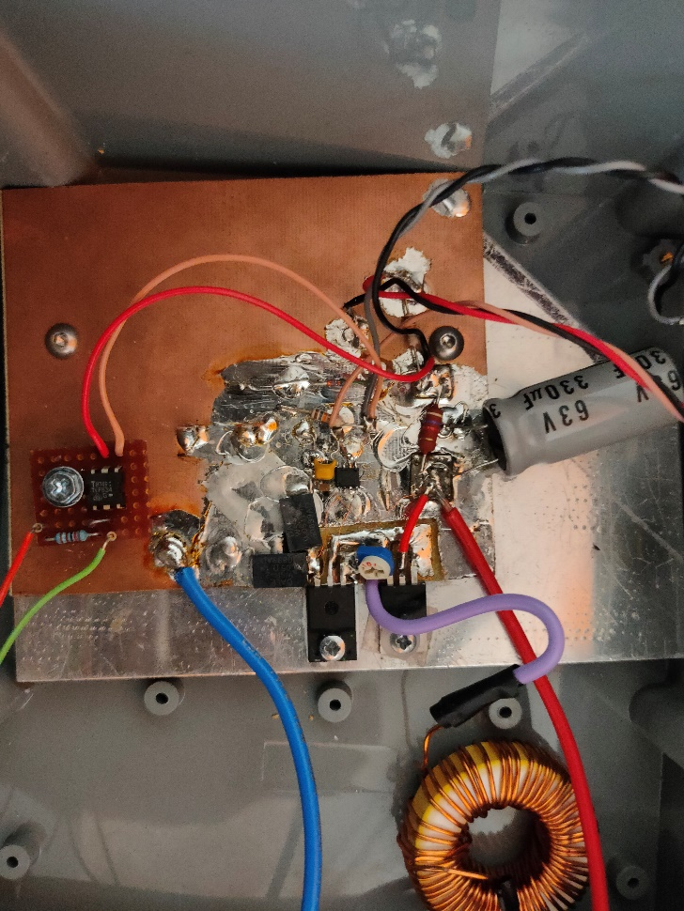

1. **Mechanical Structure Design**

In terms of the structural design chosen for the box, the requirement was that there should be a meter that shows the amount of current passing through the system as well as a switch and an adjustable knob for powering the system as well as controlling the amount of current passing through the system. The following picture shows the location of each of these components on the box.

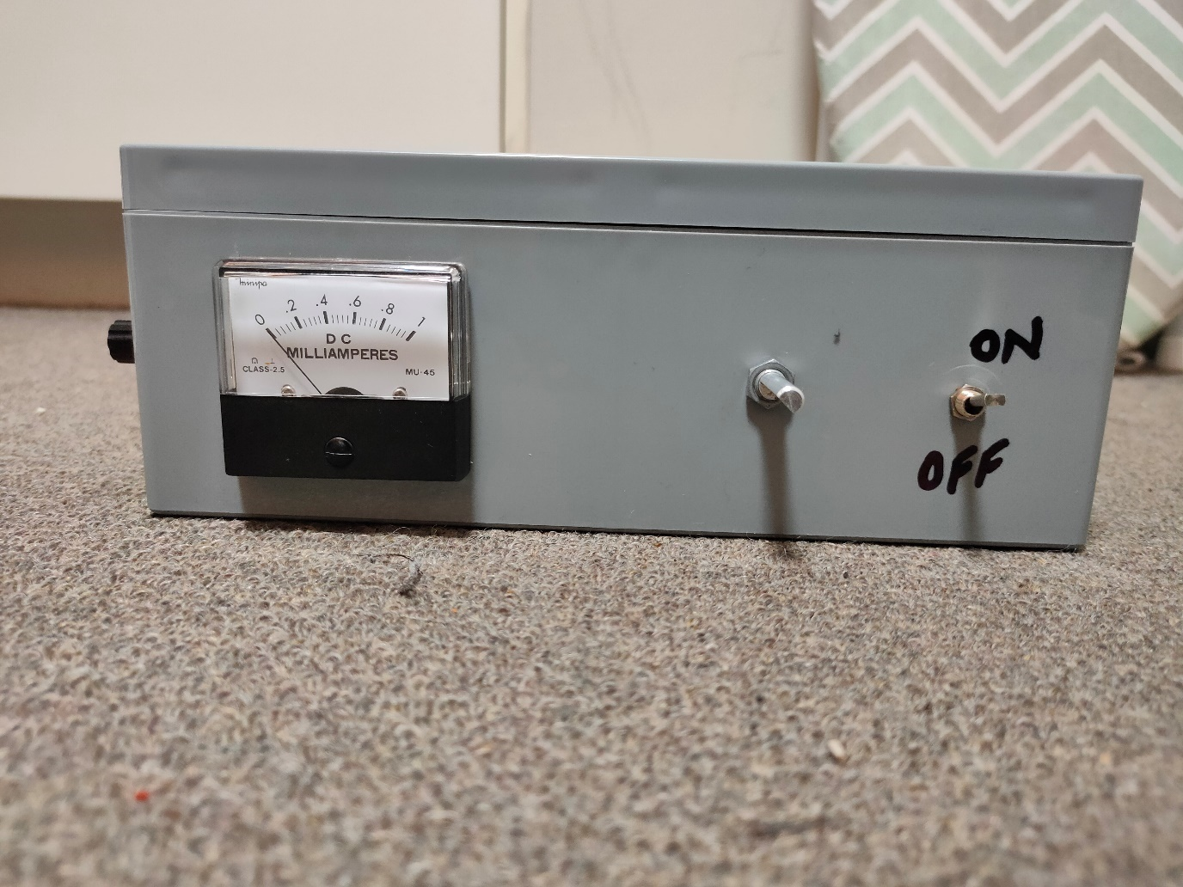

On the longer side of the rectangular box, the meter, along with the knob and the switch reside. The idea that the team agreed on was that the knob and the switch should be next to the meter so that the user can easily see the current and adjust the amount of current going through the panels. The knob was kept on the right side to prevent any awkward movements of the user’s wrist, which could be uncomfortable.

On the left side of the meter, the plugs for connection to the solar panel and the battery are made. The reason why the plugs weren’t made at the back side of the box was mainly due to how the internal position of the components are.

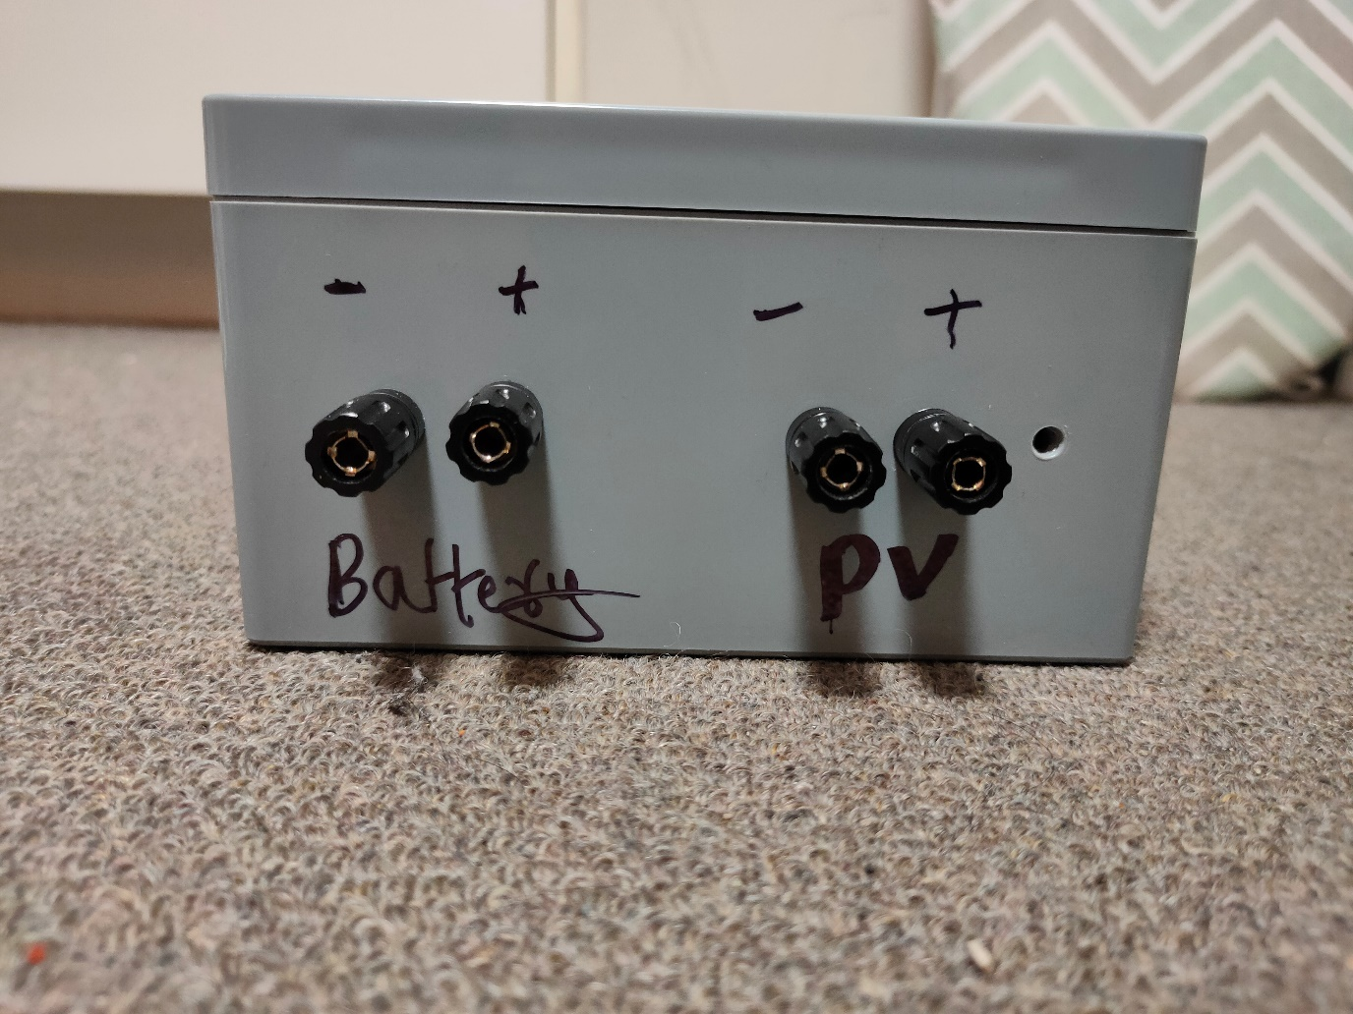

Looking into the box, the circuit regulator and the RF receiver board are placed next to each other. The rf trigger as an antenna which can either be manually attached by the user during testing, or a hole ca be drilled into the cover of the box so that the antenna can stick out and receive the signal from the transmitter that is attached to the raspberry pi.

